Module 08
Aim: Creating a virtual Storage Area Network (SAN) using Starwind.
Theory:
The Storage Networking Industry Association (SNIA) defines the storage area network (SAN) as a network whose primary purpose is the transfer of data between computer systems and storage elements. A SAN consists of a communication infrastructure, which provides physical connections. It also includes a management layer, which organizes the connections, storage elements, and computer systems so that data transfer is secure and robust. a SAN is a specialized, high-speed network that attaches servers and storage devices. The SAN is sometimes referred to as the network behind the servers. A SAN allows an any-to-any connection across the network, by using interconnect elements, such as switches and directors. The SAN eliminates the traditional dedicated connection between a server and storage, and the concept that the server effectively owns and manages the storage devices. a SAN introduces the flexibility of networking to enable one server or many heterogeneous servers to share a common storage utility. A network might include many storage devices, including disk, tape, and optical storage. Additionally, the storage utility might be located far from the servers that it uses.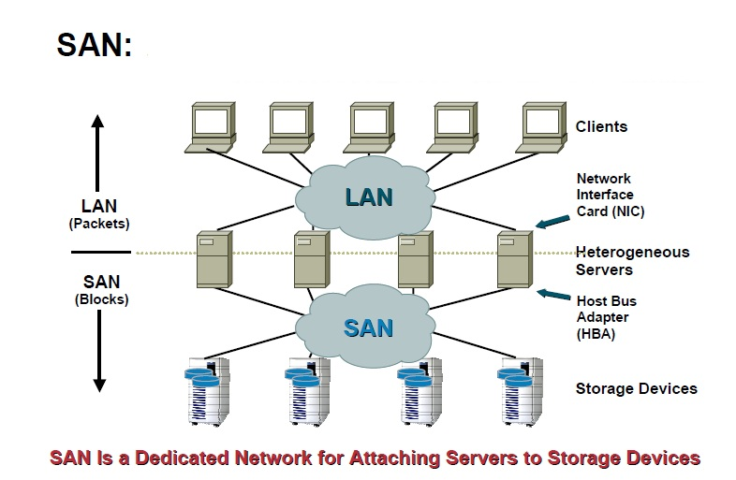
Listed below are a few main features of SAN:
- Provides block level access rather than file level access that is provided by NAS (Network Attached Storage).
- Fiber channel is the primary media used with SAN.
- SCSI is the main I/O protocol.
- SAN storage appears to the computer as its own storage.
- It can have excellent speeds and performance when used with fiber channel media.
- Used primarily for higher performance block level data storage.

Creating virtual SAN using Starwind;

Starwind is a software from the company Starwind Software Inc. Starwind is the software that eliminates any need in physical shared storage by basically “mirroring” internal hard disks and flash between hypervisor servers. There is less hardware to buy in general, consequently less money is spent on purchase and maintenance. The existing hardware is used with maximum efficiency, so there is no money wasted at all.
StarWind can be used as shared storage for almost any application. It is fully compatible with VMware, Hyper-V, or server clusters for applications such as SQL Server, Exchange, and SharePoint. Starwind Virtual SAN is the software meant for the people who want to build and maintain virtualization infrastructure at little to no expenses.

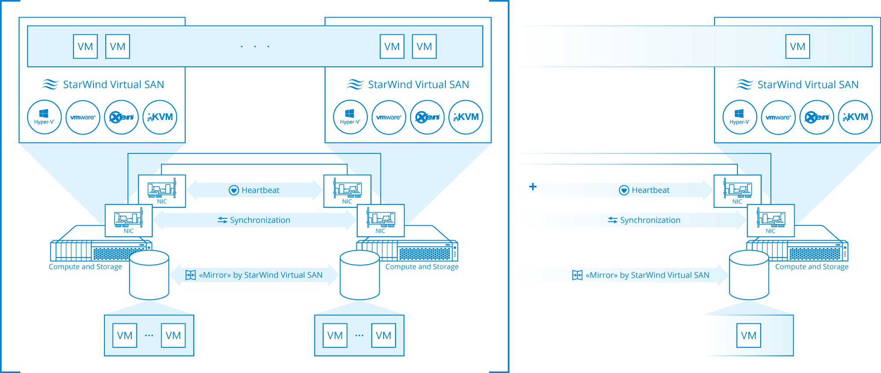

Benefits of using Starwind Virtual SAN:
- Simplicity: Simplicity is a key feature. StarWind Virtual SAN runs as a native hypervisor component or in VM, and it does not require any deep storage and network administration or UNIX management skills. A typical system administrator with minimal experience in Hyper-V, VMware or Windows can install, configure and maintain VSAN operations.
- Low cost: StarWind Virtual SAN cuts the cost at least in half, meaning both Operational and Capital Expenditures. It eliminates the actual physical shared storage, corresponding infrastructure, as well as associated deployment and maintenance activities. StarWind VSAN works on commodity components, so there is not only less hardware to purchase and maintain, but also the required hardware is inexpensive.
- High performance: Performance is uncompromised by the minimalistic hardware footprint, reduced deployment and management costs. StarWind Virtual SAN brings to the table server-side flash and memory caches, log-structuring and an absolutely minimalistic I/O path. The resulting performance is unmatched by either typical virtual appliances or physical shared storage.
Step by step Procedure to create virtual SAN using Starwind:
- Installation of Starwind software.
- Download the setup file from https://www.starwindsoftware.com/download-starwind-products.
- Launch the setup file downloaded in previous step on the server that we want to turn into SAN storage.
- The setup wizard will start, click “Next”.
- Read and accept the license agreement. Click “Next”.
- The setup wizard will display some important information. Read it carefully and click “Next”.
- Select the installation path by click the Browse button. Click “Next”.
- Starwind offers three types of installations:
- Starwind iSCSI service:- This installation type is applied to remote access servers. StarWind Service enables the creation of various devices (e.g. HA devices, Snapshot, CDP, and Mirror devices) and can be managed with StarWind Management Console from another computer.

- StarWind Management Console:- Management Console is the Graphical User Interface (GUI) part of the program that monitors and controls the storage related operations (e.g. allows for the creation of devices on the available target servers). After its installation, Management Console connects to StarWind Service remotely.

- Full installation:- Full installation includes both StarWind Service and Management Console elements. It allows for the management of resources from the machine with installed StarWind Service.
- Select Full installation. Click “Next” to continue.
- Specify the Start Menu Folder. Click “Next” to continue.
- Select the checkbox if you want to create desktop icon for Starwind and Click “Next“ to continue.
- If you are sure about the setting you have selected click “Install” to continue otherwise go back and make the desired changes.
- After the installation process is complete, you will be prompted to apply either a time-limited fully functional evaluation key, or a FREE version key, or a fully unlocked commercial license key that is supplied with an acquired StarWind product. Select the appropriate option. Click “Next” to continue.
- Select the appropriate checkbox to launch StarWind Management Console immediately.
- Click “Finish” to close the wizard.
B. Register the Software.
- Launch Starwind Management Console: double click stawind tray icon. The management console allows for the management of multiple Starwind servers from one computer.
- Activate Starwind Management Console by applying your License Key. Click “Apply Key” to proceed.
- Click “Load” to select and open the license file that you have received. Click “OK” to continue.
- The locally installed Starwind Service Server is listed in the servers item of the console tree. His is shown in the following screenshot:
- Click “Connect” in the toolbar to connect to the server.
- You will be prompted to enter the username and password. The default login and password are:
Username: root and password: starwind.
- Click “OK” to continue.
To Register Starwind Software:
- Select the connected server and go to the configuration tab.
- Click “Registration”. You will see the information about the license applied to this server.
- Click install to apply the license.
- Click “Load” to select and open the license file that you have received.
- Click “OK” to continue.
C. Creating a basic virtual device:
- Select the server where a new virtual device will be created. Click “add device” in the toolbar. “Add device” wizard will appear.Follow the wizard steps to complete the creation of a new image file device.
- Go to Hard Disk -> Basic Virtual -> Image file device.
- Click “Next” to continue.
- Select the create new virtual disk option. See the following screenshot.
- Click “Next” to continue.
- Specify the location, name, and size of a virtual disk in the appropriate fields. Click “Next” to continue. See the following screenshot:
- If needed, set additional parameters for your virtual disk. Click “Help” to get detailed information. See the following screenshot:
- Click “Next” to continue.
- Set caching parameters for your device. (Select “Normal – No caching”). Click “Next” to continue.
- Select target attachment method. For a new target , specify the target alias and clustering option if required. See the following screenshot:
- Check the summary of the set options. Click “Next” to continue if you do not want make any changes.
- Click “Finish” to close the wizard.
D. Accessing the virtual device from the client machine:
- On a client machine search for iSCSI Initiator setup.
- Enter username and password.
- Specify the IP address of the target machine.
- Now right click “My Compuer” / “This PC”. Select “Manage”
- Select “Disk Management”.
- You are able to see the disk (virtual device) that you created before. Right Click and Select “Format”. Once you format the disk it becomes available for use on client machine.

Conclusion: A virtual hard disk of the required size is created on the Starwind server and accessed on the client machine.
Program  Execution/  formation/  correction/  ethical practices  (07) | Documentation  (02) | Punctuality  (01) | Viva Answer  (05) | Experiment  Marks (15) | Teacher Signature with date

